**Cloud Application Development**

**Architectural Styles**

For

E-Yug App

Submitted By

|  |  |  |
| --- | --- | --- |
| **Specialization** | **SAP ID** | **Name** |
| CCVT | 500087939 | Ankush Katiyar |



Department of Systemics

School Of Computer Science

UNIVERSITY OF PETROLEUM & ENERGY STUDIES,

DEHRADUN- 248007. Uttarakhand

**Project Submitted to**

**Mr. Saurabh Shanu**



**School of Computer Science**

University of Petroleum & Energy Studies, Dehradun

**Report**

**Project Title**

E-Yug App

**Abstract**

Everyday lakhs of labours, workers stand on roadside waiting for people to come and hire them on daily wage basis for building house, construction work etc, further it is difficult to find a work specialist for specific work.

The main part of this project is to develop an automated system which build a communication path and strengthen the customer-worker relationship. This system also helps to reduce the time and effort in searching workers efficiently. Also, this system makes a worker to obtain suitable work of his/her category throughout the year and enhance his/her financial status.

**Introduction**

Application for daily wage workers, where workers get work and the customer get the services from the workers like Plumber,Carpenter,Electrician,Mason etc

People nowadays are having difficulty obtaining qualified professionals to do their tasks. Workers may not be available when needed or may be inefficient.

Their efforts. Furthermore, many workers will not receive work on a daily basis, making it impossible for them to meet their basic demands. This creates a significant dilemma for the individual whose work is to be done (referred to as 'clients' from now on) and workers.

To circumvent these issues, we created a system in which anyone can book personnel based on their location or area. Workers will be able to register with the application at any moment. The information about registered workers is processed and supplied to the consumer.

The customer can then select any labours (workers), for which an e-mail notification will be issued to the system administrator with the necessary details. Admin, in turn, communicates with the concerned worker, and the worker may be assigned to work at the customer's location. When the work is over, the worker approaches the system administrator and presents work details.

Based on this, Admin will send the bill information to the consumer in question for payment. This system will enable the administrator to generate a variety of reports in order to keep track of both client and worker information. Additionally, admin offers capabilities for managing overall worker statistics such as availability, grant leave, and so on.

**Why Deploying on cloud**

* E-Yug will be publically available to the worker as well as customer.
* User when going out physically for hiring worker is bit tough task which consumes high cost and also workers looking for work have to spend his time and money to find work and so cost reduction
* Scalability - App will get user track and labour track. Real time access from anywhere.
* Real time availability
* Monitry and measurement

**Application Platform Using**

For the deployment of the application AWS (Amazon Web Services) will be used.

AWS is **easy to use** as it is intended to enable application providers, ISVs, and vendors to swiftly and securely host their applications, whether they are existing or new SaaS-based apps. To access AWS's application hosting platform, you can utilise the AWS Management Console or well-documented web services APIs.

AWS offers **flexibility**, You can choose the operating system, programming language, web application platform, database, and other services you require from AWS. AWS provides you with a virtual environment in which you can load the software and services that your application requires.

It is really **cost effective**, There are no long-term contracts or up-front obligations, and you just pay for the compute power, storage, and other resources that you utilise. See the AWS Economics Center for additional information on comparing the costs of various hosting choices to AWS.

It offers **high scalability** and has **high performance**.

To secure and fortify our infrastructure, AWS employs an end-to-end approach that includes physical, operational, and software safeguards. See the AWS Security Center for further details.

There are multiple regions available to users in AWS where they can store both information and instances. Such regions consist of availability zones protected from failures in other zones.

**Literature Review**

Standardized mobile business apps often offer a limited range of features. Existing mobile apps and studies on mobile collaboration are mostly concerned with knowledge.

work, and so on mobile knowledge workers. Mobile collaboration, however, is not limited to knowledge-intensive businesses with volatile work conditions.

This study demonstrates that different types of mobile technologies are required for different categories of mobility workers on a regular basis and very few of these app have been deployed on cloud. This research recognised two ideal kinds of mobile employees with distinct needs for mobile support: the mobile knowledge worker and the mobile field worker. Both groups operate in quite distinct business environments.

One of the gaps found was there were no proper instruction in the app for labour as well customer and in country like India languages like Hindi, English, Urdu and several other languages are spoken and so instruction can be given in some common language.

**Problem Statement**

* Workers and customers can now directly connect to eachother without any intermediater or  hazel.
* Covering all the limitation and act as a bridge between customer and labour.

**Flow Chart**

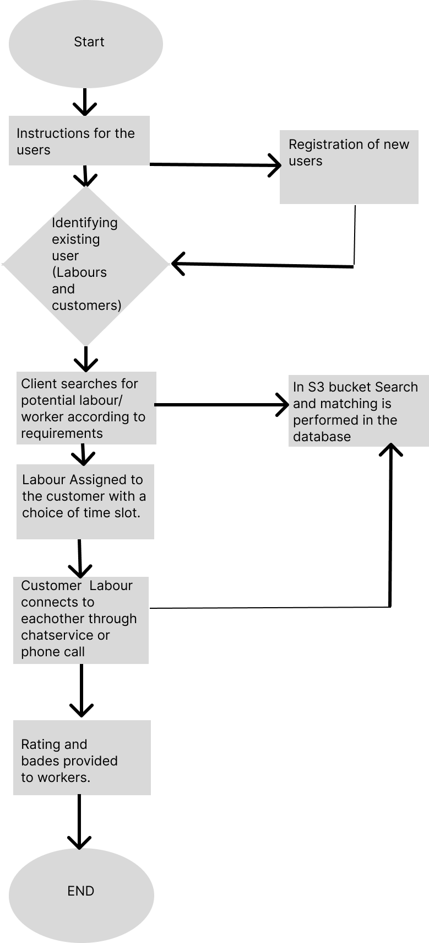

**References**

1. <https://www.ilo.org/wcmsp5/groups/public/---dgreports/---dcomm/---publ/documents/publication/wcms_645337.pdf>
2. <https://www.irjet.net/archives/V6/i4/IRJET-V6I4798.pdf>
3. <https://www.researchgate.net/publication/301931650_Designing_for_Labour_Uber_and_the_On-Demand_Mobile_Workforce>

1. <https://www.researchgate.net/publication/273505260_Mobile_Applications_for_Knowledge_Workers_and_Field_Workers>

1. <https://timesofindia.indiatimes.com/business/india-business/india-largest-provider-of-online-labour/articleshow/59675046.cms>